**Network Traffic Analysis**

**Using Wireshark**

Network traffic analysis plays a vital role in both cybersecurity and network administration. One of the most powerful tools available for this task is Wireshark, a widely adopted open-source network protocol analyzer. It allows users to capture, filter, and inspect data packets as they traverse a network, helping identify suspicious activity, troubleshoot issues, and ensure data security.

**Getting Started with Wireshark**

To begin analyzing traffic, we must first choose the appropriate network interface—such as Ethernet or Wi-Fi—from which to capture packets. Once a capture session starts, Wireshark records all traffic flowing through the selected interface in real time.

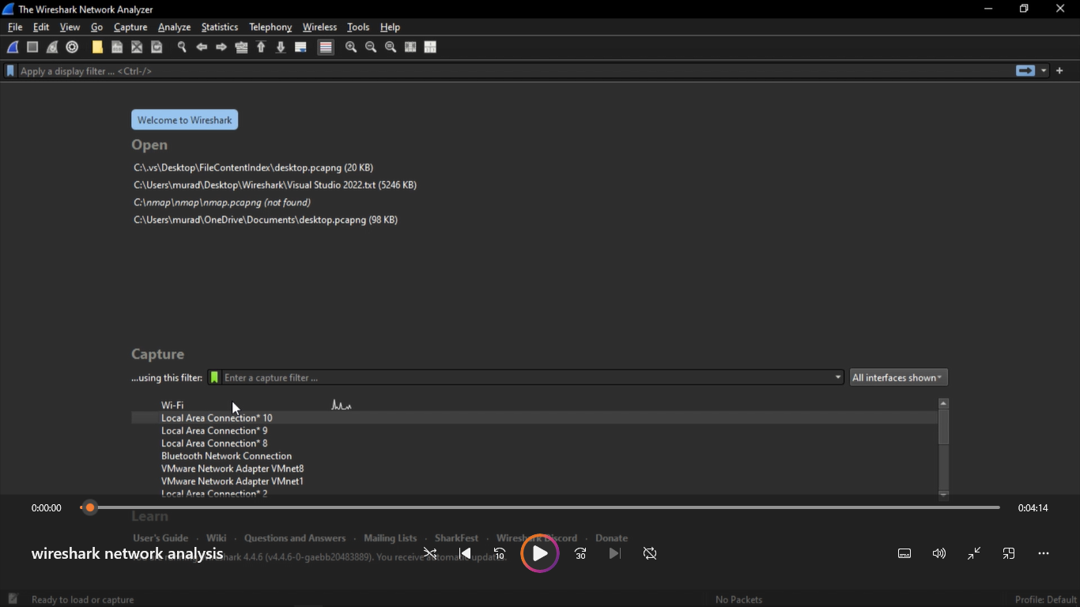

**Using Filters to Focus the Analysis**

Wireshark offers advanced display filtering capabilities that help narrow the scope of traffic being analyzed. Located at the top of the interface, the display filter bar allows users to isolate traffic based on specific parameters such as:

* IP addresses
* Protocols (e.g., TCP, HTTP, DNS)
* Port numbers

For example, applying the filter:

“ip.addr == 192.168.191.154”

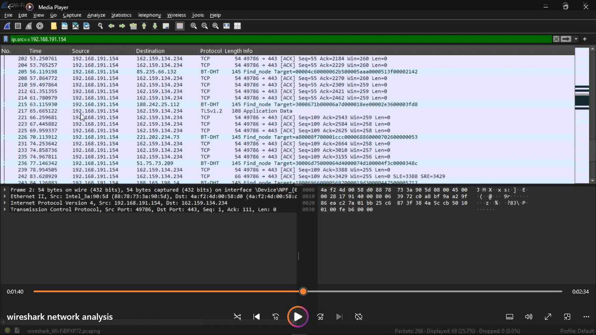

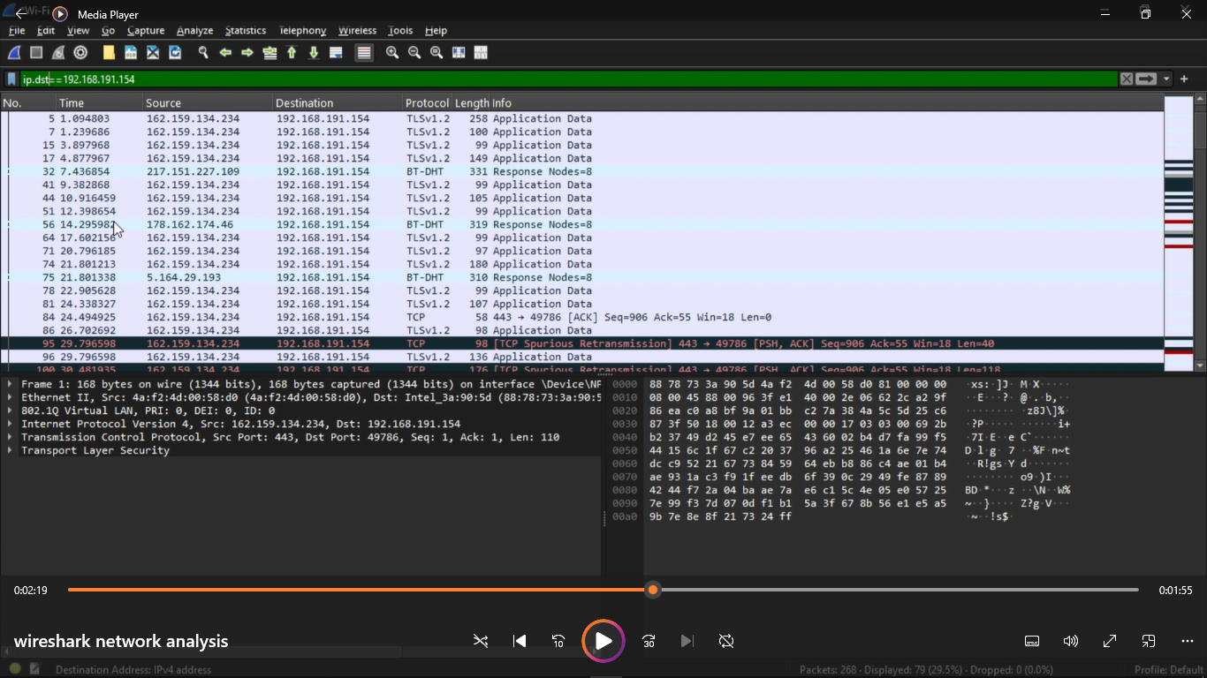

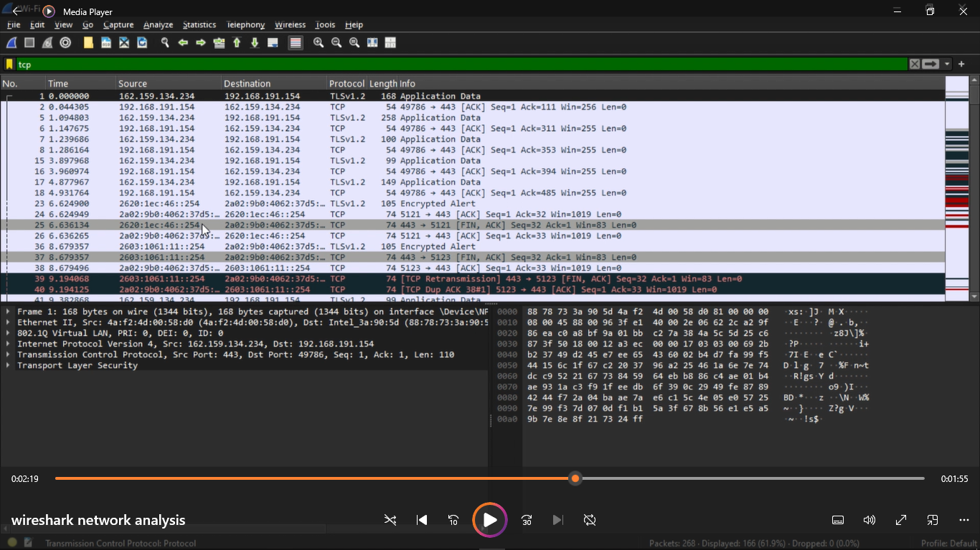

displays only the traffic sent or received by the specified IP address, allowing analysts to quickly zero in on relevant packets.

**Investigating Suspicious IP Addresses**

When unusual IP addresses are detected, validating their legitimacy is essential. Tools like VirusTotal and Talos Intelligence can be used to assess the risk level of an IP address:

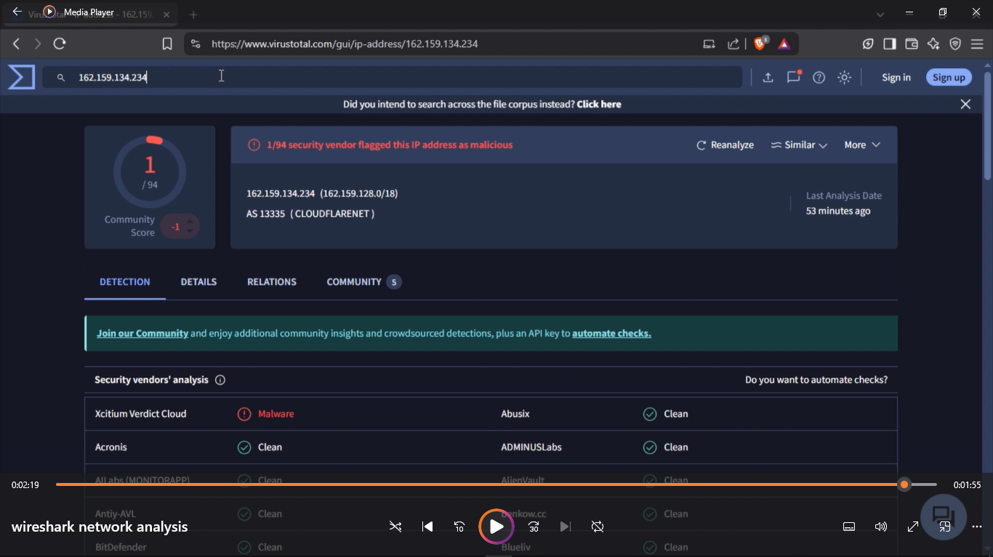

* VirusTotal aggregates threat intelligence from multiple sources to determine if the IP is linked to known malicious behavior.
* Simply enter the IP into the search bar on VirusTotal.com to view detailed threat analysis reports.
* This helps analysts make informed decisions on whether to flag, block, or further investigate the entity.

**Recognizing Suspicious Network Activity**

Suspicious activity on a network typically indicates potential security threats. This may include:

* Unauthorized access attempts
* Unusual data transfers
* Communications with blacklisted or malicious IPs
* Irregular traffic patterns or protocol usage

These anomalies may point to threats such as malware, data exfiltration, or intrusion attempts. It's critical for organizations to have strong monitoring and response mechanisms to identify such issues early.

Examples of Suspicious Network Behavior

1. Malicious Database Activity

Unapproved changes in database users, permissions, or data may suggest compromise.

2. Privileged Account Abuse

Insider threats often involve misuse of admin accounts, altered audit logs, and unauthorized access to confidential data.

3. Unusual User Access

Changes in login times, geographic locations, or device types may indicate compromised credentials or external attacks.

4. Unauthorized Configuration Changes

Sudden changes to system files or settings can be evidence of tampering or breaches.

5. Abrupt Network Behavior

Increased latency, traffic from unknown origins, or unauthorized network scanning attempts often signal active infiltration attempts.

6. End-User Observations

In smaller organizations, users may notice signs of suspicious activity before security systems do—such as system slowdowns, pop-ups, antivirus alerts, or unauthorized toolbars.

**Preventing Suspicious Network Activity**

To strengthen network defenses and proactively prevent threats, organizations should adopt a layered approach to security:

1. Understand and Classify Data

Know what data exists, where it is stored, who accesses it, and how it flows.

Categorize data by sensitivity and compliance requirements.

Apply specific protections tailored to each data type.

2. Monitor Continuously

Use monitoring tools to track user activity, system changes, and traffic patterns.

Implement real-time alerting for anomalies using log aggregators, SIEMs, or cloud-native solutions.

3. Enforce Security Controls

Apply encryption to protect data in transit and at rest.

Use firewalls, VPNs, and network segmentation to control access.

Adopt strict identity and access management policies with multi-factor authentication and role-based permissions.

4. Keep Policies Up to Date

Regularly review security, governance, and privacy policies.

Align them with evolving business needs, compliance requirements, and industry standards.

Train employees to understand and adhere to these policies.

5. Conduct Regular Audits

Perform internal or third-party audits to ensure policy enforcement and regulatory compliance.

Use audit findings to identify gaps and continuously improve security postures.

6. Learn and Adapt

Stay current with cybersecurity trends, threat intelligence, and best practices.

Review past incidents and industry case studies to improve future responses.

Build a culture of continuous improvement and adaptability.

By combining vigilant network traffic analysis with a strategic security framework, organizations can detect threats early, respond effectively, and maintain control over their digital environments. Wireshark remains an invaluable tool in this ecosystem, offering deep visibility into the behaviors and anomalies that matter most.